**Sefton IDVA / MARAC Online Referral Portal – Guidance Notes**

A new online referral portal is being brought in for all referrals being made to both Sefton IDVA Team and MARAC. The aim of this is to streamline the referral process and make it easier for support to be offered to high risk victims of domestic abuse.

The online referral portal can be accessed via [**IDVA and MARAC Referral Form**](https://app.oasiscloud.co.uk/OASISDA/Core/Public/Referral/group_online_referral.aspx?apikey=bf603b7b-fcdb-4c0d-a40f-1edf42d2c477)

**General Guidance**

The following guidance notes will take you through the full online referral process. It is really important that, if safe to do so, you ascertain as much information as possible from the victim at the time of disclosure. If appropriate, the referral form can be completed with the victim present, in order to ensure that all relevant information is recorded.

The fields indicated by RED text are mandatory fields and must be completed for the referral to progress. The language used within the referral should be clear, concise and fact based.

The person completing the referral, should work down each page before moving to the next tab.

**Referral Details**

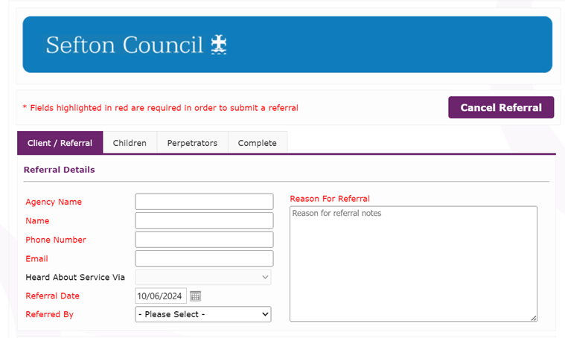

It is important that the referrer include all of their details on the referral form so that we can easily make contact if there are any queries or issues with the submitted referral.

The reasons of referral should be kept concise, and fact based, the information included should focus on the current domestic abuse concerns and contain details of any domestic abuse incidents which have taken place in the previous **3 month** period.

**Client Details**

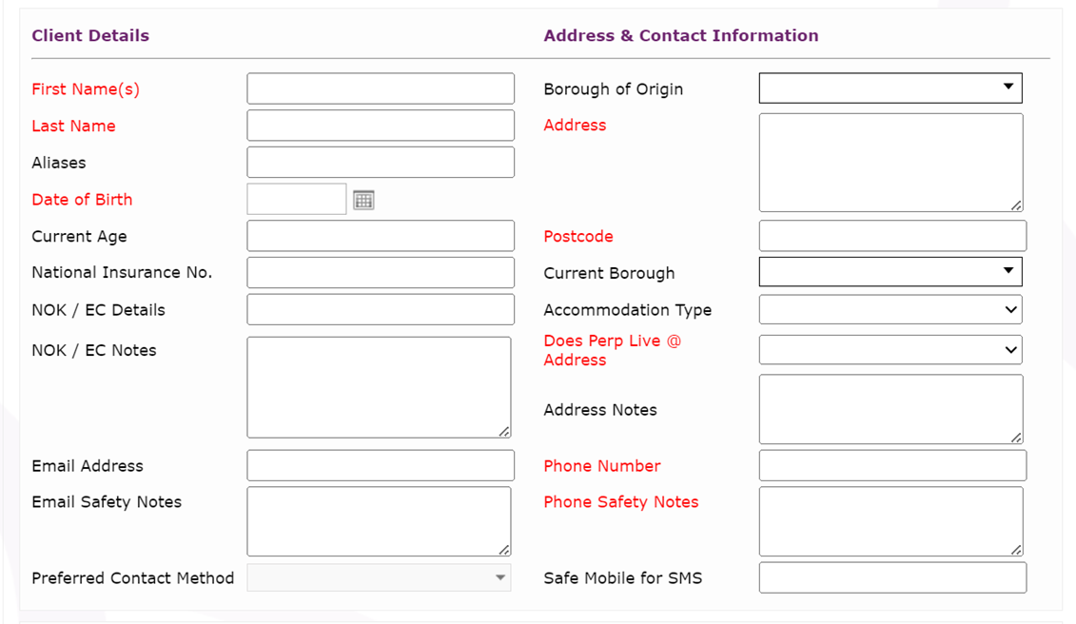

Once the referrer details and the reasons for the referral have been completed, you should work through the client details and complete with as much information as possible. Whilst only the fields marked in RED are mandatory, it is still important to complete as many of the other fields as possible.

**Equalities, Accessibility and Vulnerabilities**

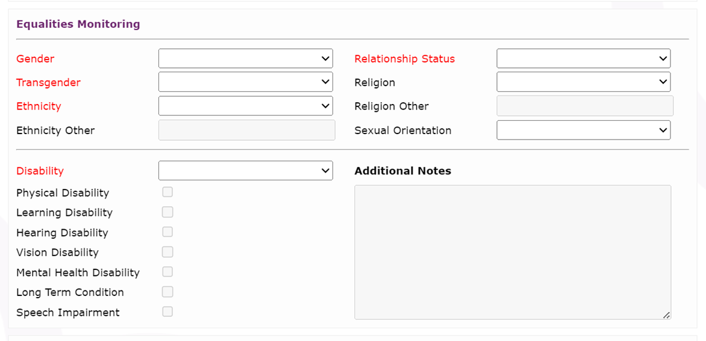

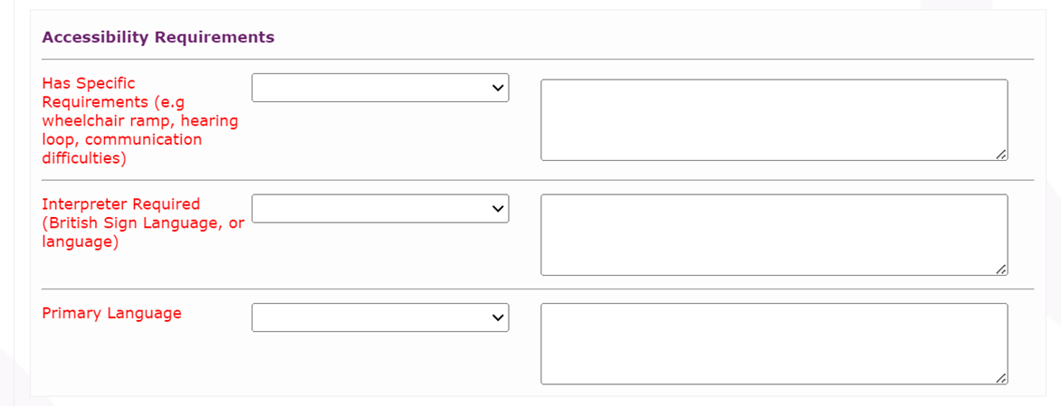

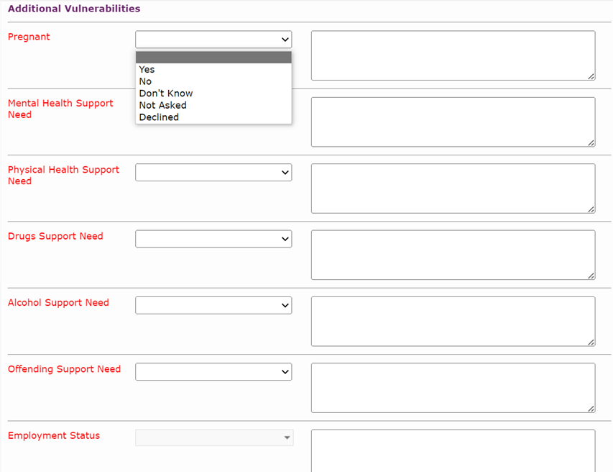

Research shows that certain demographics and vulnerabilities can put DA victims at a higher risk. Therefore, by providing as much detail as possible in relation to Equalities, Accessibility Issues and Vulnerabilities, you will enable IDVA to adapt their contact attempts to the client as appropriate to take any identified vulnerabilities into consideration. This will also enable clients to feel confident in the support that they are being offered.

If you are unsure of any vulnerability information or if it is not safe to ask when completing the referral, then there is an option for this, but this should only be used in exceptional circumstances where there is a clear rationale.

All drop down boxes also have a free text box next to them for you to record further information to ensure efficient processing.

If you are aware of any other agencies supporting the victim with a particular vulnerability, then please write this in the box.

**Document Upload**

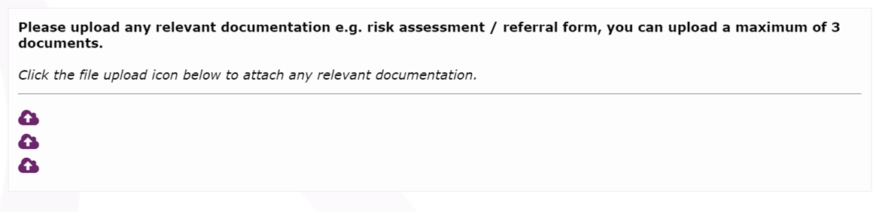

At the bottom of the first page there is a space to upload the completed DASH referral. This is a MANDATORY requirement and any referral without the DASH attached will be returned to you resulting in a delay for the victim.

You can also upload any other documents that you feel are relevant.

**Children Details**

Once the Client/Referral details have been completed, please move to the next tab and complete the details of any children. Multiple children can be added to the referral – once the details of the first child have been entered, press the ‘Add a Child’ button and complete the details of the next child. The ‘Add a Child’ button can be used as many times as needed.

If the case does not include any children, then please skip the children tab and move onto the perpetrator tab.

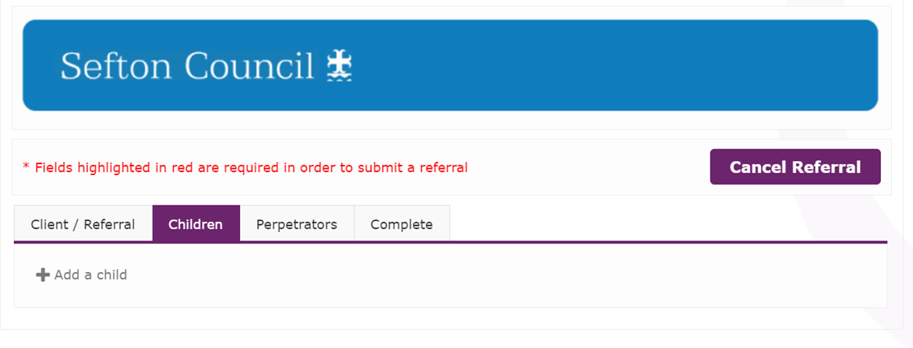

The details to be provided for the child(ren) are very similar to that of the client. The key information to include is name, DOB and address of the child. Other key information is details of any social care or early help involvement and the relationship of the child to the perpetrator.

**Perpetrator Details**

Once the child(ren)s details have been completed, or if there are no children involved, please click on the perpetrator tab and add the details of the perpetrator. Again, the details to be provided for the perpetrator are very similar to the ones previously provided for both the client and any children.

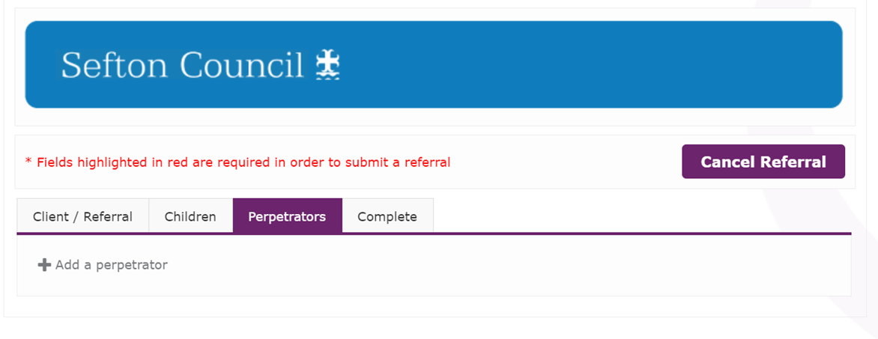

As with the client details, it is important that as much information as possible is provided for the perpetrator including in relation to equalities, accessibility and any vulnerabilities. This is important as it will provide further information to IDVA to allow them to adjust their offers of support to the client accordingly.

If you are unsure of any vulnerability information or if it is not safe to ask when completing the referral, then there is an option for this, but this should only be used in exceptional circumstances where there is a clear rationale.

**Referral Submission**

Once all of the relevant tabs have been completed as fully as possible, please click on the complete tab and press the submit referral button.

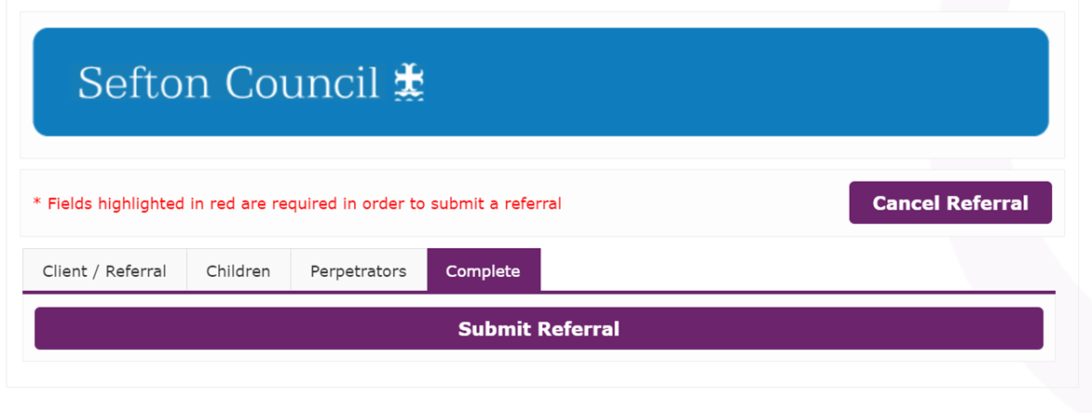

**Missing Information**

Before submission there is an inbuilt check on the system to ensure that all relevant, mandatory information is completed. If any mandatory fields have been missed, then they will be listed in red, as per the picture below, to allow you to easily identify them and go back and complete them. YOU WILL BE UNABLE TO SUBMIT THE REFERRAL UNTIL ALL MANDATORY FIELDS HAVE BEEN COMPLETED.

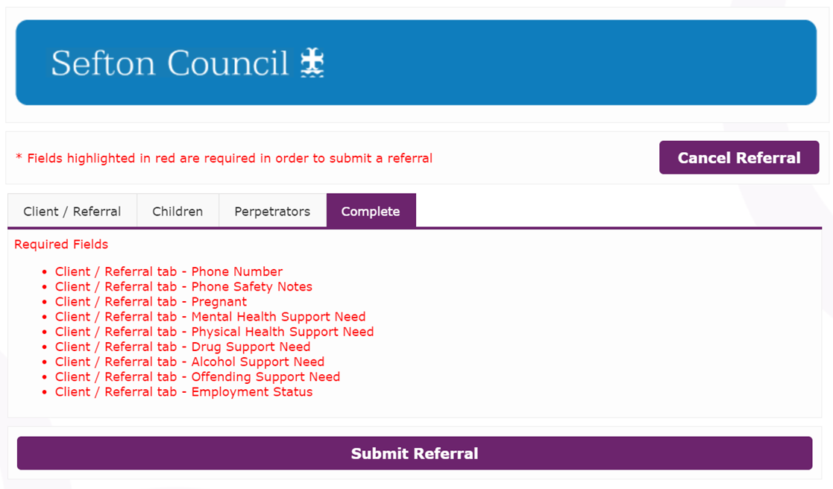

**Following Submission**

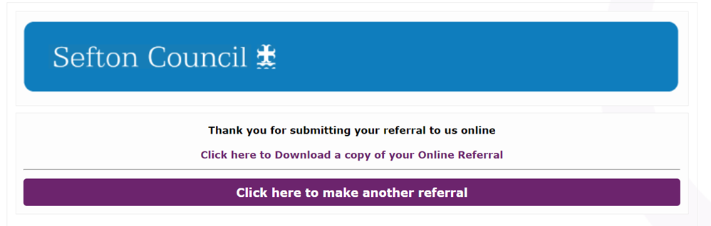

Once the referral has been submitted, it will be quality assured by the MARAC / IDVA Teams and if there are any issues or if the referral is unsuitable, this will be fedback to the referrer.

If the referral is accepted, the IDVA duty worker will attempt contact with the victim within 24 hours in order to offer support.

If the referral is also for MARAC, the case will be listed for discussion at the next available MARAC meeting.